Citizen Social Science Course
Learning Assessment Booklet

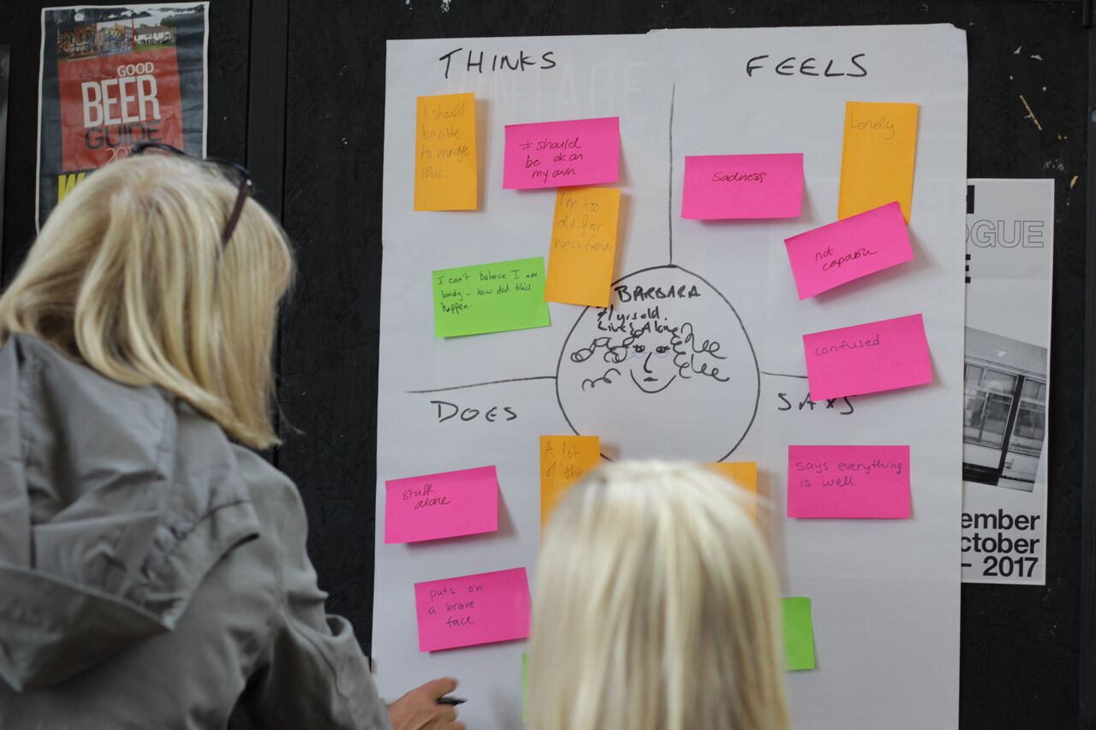

TInnGO Hub:
Participant name
Participant ID number
Start date
Completion date

Citizen social science units – learning outcomes and assessment criteria
Learning outcomes | Assessment criteria
1. Understand the principles of citizen social science | - Summarise the principles of Citizen Social Science  - Describe the role of a citizen social scientist  - Describe the various organisations that may work with Citizen Social Scientists
2. Understand the importance of citizen social science in own area | - Define social research.  - Outline topics that may be explored in own area.
3. Be able to reflect on own learning | - Reflect on learning from study of Citizen Social Science.  - Explain improvements that can be made.

Learning outcomes | Assessment criteria
1. Understand peer research. | - Explain the meaning of peer research.  - Explain reasons to conduct peer research.
2 Know how to carry out peer research. | - Describe research methods.  2.2 Explain potential ethical issues that may arise during research.
- Be able to plan a peer research project. | 3.1 Design a peer research project
- Be able to carry out a peer research project. | - Carry out a piece of peer research using appropriate research methods.
- Know how to evaluate own research. | - Explain the impact of research methods used.  - Summarise difficulties that have arisen during the research.  - Review own learning on completion of research project.  - Present findings (in a report of presentation)
Conducting peer research units – learning outcomes and assessment criter
Notes

Session 1: Introduction to Citizen Social Science

Summarise the principles of CSS. Describe the role of a citizen social scientist. Define social research. Describe the various organisations that may work with citizen social scientists.

- Summarise what citizen social science is.

- Describe what a citizen social scientist does.

- Define social research.

- Describe the organisations which might work with citizen social scientists.

Session 2: Identifying topics and designing research questions

Outline topics that may be explored in own area
Instructions:
- Write three ideas for topics which could be explored by a citizen social scientist. Think about Coventry city and your neighbourhood. Start thinking about what topic you want to explore in your research project, and why.
- Then, please write down a sentence explaining why you have chosen that specific topic for research.

Research topic 1:

Explain briefly why you chose this topic:

Research topic 2:

Explain briefly why you chose this topic:

Research topic 3:

Explain briefly why you chose this topic:

Session 3: Introduction to methods

Explain the meaning of peer research. Explain reasons to conduct peer research. Describe research methods.
1) What is peer research?

2) Explain what research methods are and why we use them

3) Explain the main difference between quantitative and qualitative research approaches

4) Identify one qualitative and one quantitative research method

5) Identify one advantage and one disadvantage of using the survey method

6) Identify one advantage and one disadvantage of conducting semi-structured and unstructured interviews

7) Explain what is meant by ‘photo elicitation’

Session 4: Research ethics

Explain potential ethical issues that may arise during research.

1) What are ‘research ethics’?

2) Explain why research ethics are important?

3) List the six core elements of ethical research

4) Describe two of the core elements of ethical research in more detail

Session 5: Research design and project planning

Design a peer research project

Instructions:
Fill in the project plan template below
Research question:
(Choose a question that you will be able to answer in the time available, using methods you have learned about)

Outline the method(s) you will use to answer your research question:
(Make sure the method(s) you choose will help you to answer your research question)

Write about how you will record your findings:
(e.g. in an observation diary, on a survey, or through visual representations such as photographs)

Outline any ethical considerations which might arise, and describe how you will address these:
(Think about how you will gain informed consent, how will you protect the privacy of any participants, how you will ensure your own welfare and the welfare of your participants.)

Finally, think about what you need to do to prepare for your fieldwork. Write a plan here if it will help you:
(For example, do you need to write interview questions? Do you need to practice doing the interview with another student? Do you need to practice using the camera? Make a survey? Create an observation diary?)

Sessions 6 and 7: Fieldwork

Carry out a piece of fieldwork using appropriate research methods.
- Summarise what your fieldwork is about

- Describe what went well with your fieldwork

- Describe any difficulties you had

- Describe some of your findings

Session 8: Presentation preparation

Summarise difficulties that have arisen during the research. Review own learning on completion of research project
1) What challenges did you encounter while conducting your research?

2) Explain how you overcame these difficulties?

3) If you could do your research again, what would you do differently? Please explain why.

4) What are the two main things you have learnt from conducting research? Why are they important to you?

